ASSIGNMENT-1 A.Sridhar

191911140

Programming in java Cse

CSAO978

1)

import java.util.Scanner;

public class Q1

{

  public static void main(String args[])

  {

 Scanner sc = new Scanner(System.in);

System.out.println("Enter the no of rows: ");

  int n=sc.nextInt();

    int row, column;

    for(row=0; row<n; row++)

    {

      for(column=0; column<=row; column++)

      {

        System.out.print("\* ");

      }

      System.out.println();

    }

  }

}

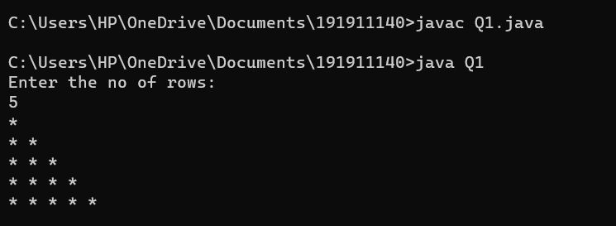

2)

public class Q2 {

    public static void main(String[] args) {

        int numRows = 5;

        int[][] numbers = new int[numRows][numRows];

        for (int i = 0; i < numRows; i++) {

            for (int j = 0; j <= i; j++) {

                if (j == 0 || j == i) {

                    numbers[i][j] = 1;

                } else {

                    numbers[i][j] = numbers[i-1][j-1] + numbers[i-1][j];

                }

            }

        }

        for (int i = 0; i < numRows; i++) {

            for (int j = 0; j < numRows-i-1; j++) {

                System.out.print(" ");

            }

            for (int j = 0; j <= i; j++) {

                System.out.print(numbers[i][j] + " ");

            }

            System.out.println();

        }

    }

}

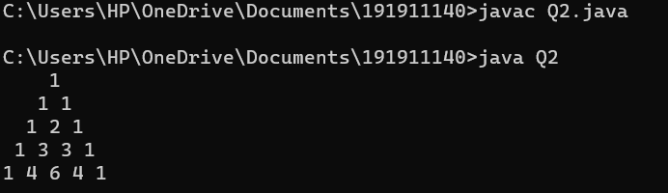

3)

import java.util.Scanner;

public class Q3 {

    public static void main(String[] args) {

        Scanner scanner = new Scanner(System.in);

        System.out.print("Enter the symbol: ");

        String symbol = scanner.nextLine();

System.out.print("Enter the number of rows: ");

        int numRows = scanner.nextInt();

        System.out.print("Enter the number of columns: ");

        int numColumns = scanner.nextInt();

        for (int i = 0; i < numRows; i++) {

            for (int j = 0; j < numColumns; j++) {

                System.out.print(symbol);

            }

            System.out.println();

        }

    }

}

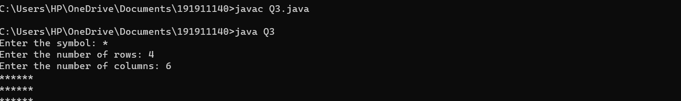

4)

import java.util.Scanner;

public class Q4 {

    public static void main(String[] args) {

        Scanner scanner = new Scanner(System.in);

        System.out.print("Enter the number to printed: ");

        int num = scanner.nextInt();

        System.out.print("Max Number of times printed”);

        int maxTimes = scanner.nextInt();

        for (int i = 1; i <= maxTimes; i++) {

            for (int j = 1; j <= i; j++) {

                System.out.print(num + " ");

            }

            System.out.println();

        }

    }

}

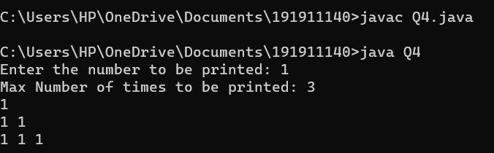

5)

import java.util.Scanner;

public class Q5{

    public static void main(String[] args) {

        Scanner scanner = new Scanner(System.in);

        System.out.print("Enter the number of rows:");

        int numRows = scanner.nextInt();

        for (int i = numRows; i >= 1; i--) {

            for (int j = 0; j < numRows - i; j++) {

                System.out.print(" ");

            }

            for (int j = 1; j <= 2 \* i - 1; j++) {

                System.out.print("\*");

            }

            System.out.println();

        }

    }

}

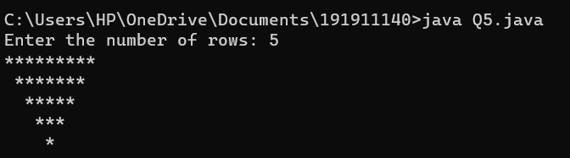

6)

import java.util.Scanner;

public class InvertedPyramidPattern {

    public static void main(String[] args) {

        Scanner scanner = new Scanner(System.in);

        System.out.print("Enter the number of rows:");

        int numRows = scanner.nextInt();

        for (int i = numRows; i >= 1; i--) {

            for (int j = 0; j < numRows - i; j++) {

                System.out.print(" ");

            }

            for (int j = 1; j <= 2 \* i - 1; j++) {

                System.out.print("\*");

            }

            System.out.println();

        }

    }

}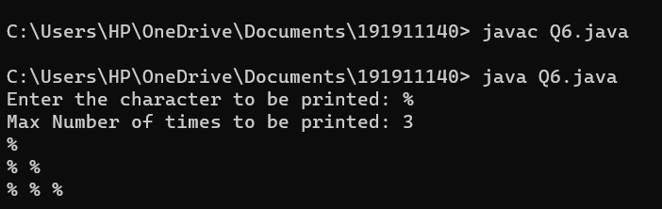

7)

import java.util.Scanner;

public class Q7 {

    public static void main(String[] args) {

        Scanner scanner = new Scanner(System.in);

        System.out.print("Enter the size of the square: ");

        int size = scanner.nextInt();

        for (int i = 1; i <= size; i++) {

            System.out.print("\*");

        }

        System.out.println();

        for (int i = 2; i <= size - 1; i++) {

            System.out.print("\*");

            for (int j = 2; j <= size - 1; j++) {

                System.out.print(" ");

            }

            System.out.print("\*");

            System.out.println();

        }

        for (int i = 1; i <= size; i++) {

            System.out.print("\*");

        }

    }

}

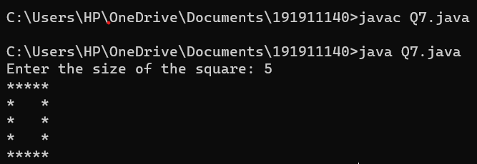

8)

import java.util.Scanner;

public class Q8 {

    public static void main(String[] args) {

        Scanner scanner = new Scanner(System.in);

        System.out.print("Enter the number of rows:");

        int numRows = scanner.nextInt();

        for (int i = 1; i <= numRows; i++) {

            for (int j = 1; j <= i; j++) {

                System.out.print(i + " ");

            }

            System.out.println();

        }

    }

}

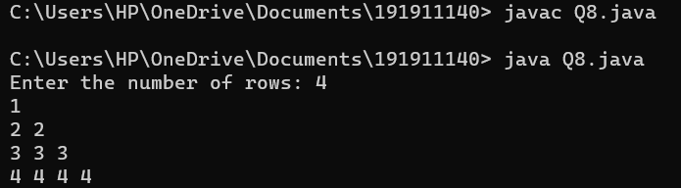

9)

import java.util.Scanner;

public class Q9{

    public static void main(String[] args) {

        Scanner scanner = new Scanner(System.in);

        System.out.print("Enter the number of rows: ");

        int numRows = scanner.nextInt();

        for (int i = 1; i <= numRows; i++) {

            for (int j = 1; j <= i; j++) {

                int num = (i-1)\*(i-1) + j\*j;

                System.out.printf("%-5d", num);

            }

            System.out.println();

        }

    }

}

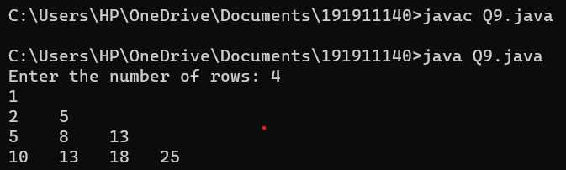

10)

public class Q10{

public static void main(String[] args) {

int rows = 4;

for (int i = 1; i <= rows; i++) {

for (int j = 1; j <= i; j++) {

System.out.print(i + " ");

}

System.out.println();

}

for (int i = rows - 1; i >= 1; i--) {

for (int j = 1; j <= i; j++) {

System.out.print(i + " ");

}

System.out.println();

}

}

}

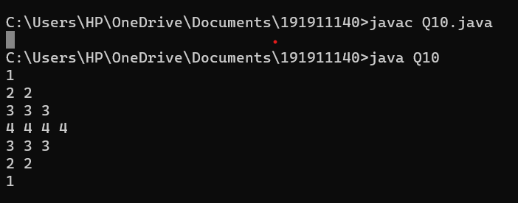

11)

import java.util.Scanner;

public class Q11 {

public static void main(String[] args) {

Scanner sc = new Scanner(System.in);

System.out.print("Enter the size of the square: ");

int size = sc.nextInt();

for (int i = 1; i <= size; i++) {

for (int j = 1; j <= size; j++) {

if (i == 1 || i == size || j == 1 || j == size) {

System.out.print("$");

}

else {

System.out.print(" ");

}

}

System.out.println(); // move to next line after each row

}

sc.close();

}

}

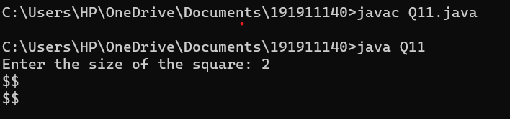

12)

import java.util.Scanner;

public class Q12 {

public static void main(String[] args) {

Scanner sc = new Scanner(System.in);

System.out.print("Enter the number of rows: ");

int rows = sc.nextInt();

for (int i = rows; i >= 1; i--) {

for (int j = 1; j <= rows - i; j++) {

System.out.print(" ");

}

for (int k = 1; k <= 2 \* i - 1; k++) {

System.out.print("\*");

}

System.out.println();

}

}

}

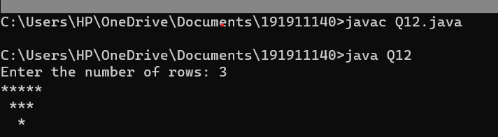

13)

import java.util.Scanner;

public class Q13{

public static void main(String[] args) {

Scanner sc = new Scanner(System.in);

System.out.println("Enter the number of rows and columns of the first matrix:");

int rows1 = sc.nextInt();

int cols1 = sc.nextInt();

int[][] mat1 = new int[rows1][cols1];

System.out.println("Enter the elements of the first matrix:");

for (int i = 0; i < rows1; i++) {

for (int j = 0; j < cols1; j++) {

mat1[i][j] = sc.nextInt();

}

}

System.out.println("Enter the number of rows and columns of the second matrix:");

int rows2 = sc.nextInt();

int cols2 = sc.nextInt();

int[][] mat2 = new int[rows2][cols2];

System.out.println("Enter the elements of the second matrix:");

for (int i = 0; i < rows2; i++) {

for (int j = 0; j < cols2; j++) {

mat2[i][j] = sc.nextInt();

}

}

if (cols1 != rows2) {

System.out.println("Matrix multiplication not possible");

return;

}

int[][] result = new int[rows1][cols2];

for (int i = 0; i < rows1; i++) {

for (int j = 0; j < cols2; j++) {

for (int k = 0; k < cols1; k++) {

result[i][j] += mat1[i][k] \* mat2[k][j];

}

}

}

System.out.println("Matrix multiplication result:");

for (int i = 0; i < rows1; i++) {

for (int j = 0; j < cols2; j++) {

System.out.print(result[i][j] + " ");

}

System.out.println();

}

}

}

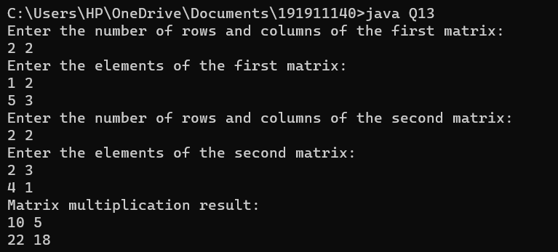

14)

import java.util.Scanner;

public class Q14{

public static void main(String[] args) {

Scanner sc = new Scanner(System.in);

System.out.println("Enter the number of rows and columns of the matrices:");

int rows = sc.nextInt();

int cols = sc.nextInt();

int[][] mat1 = new int[rows][cols];

int[][] mat2 = new int[rows][cols];

System.out.println("Enter the elements of the first matrix:");

for (int i = 0; i < rows; i++) {

for (int j = 0; j < cols; j++) {

mat1[i][j] = sc.nextInt();

}

}

System.out.println("Enter the elements of the second matrix:");

for (int i = 0; i < rows; i++) {

for (int j = 0; j < cols; j++) {

mat2[i][j] = sc.nextInt();

}

}

int[][] result = new int[rows][cols];

for (int i = 0; i < rows; i++) {

for (int j = 0; j < cols; j++) {

result[i][j] = mat1[i][j] + mat2[i][j];

}

}

System.out.println("Matrix addition result:");

for (int i = 0; i < rows; i++) {

for (int j = 0; j < cols; j++) {

System.out.print(result[i][j] + " ");

}

System.out.println();

}

}

}

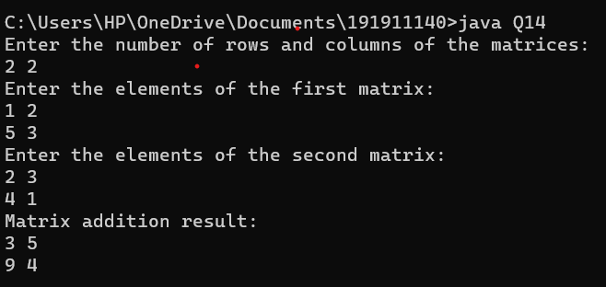

15)

import java.util.\*;

public class Q15 {

public static void main(String[] args) {

int[] arr = {16, 18, 27, 16, 23, 21, 19};

int n = arr.length;

Arrays.sort(arr);

double mean = getMean(arr, n);

int median = getMedian(arr, n);

int mode = getMode(arr, n);

System.out.println("Mean = " + mean);

System.out.println("Median = " + median);

System.out.println("Mode = " + mode);

}

static double getMean(int[] arr, int n) {

int sum = 0;

for (int i = 0; i < n; i++) {

sum += arr[i];

}

return (double) sum / n;

}

static int getMedian(int[] arr, int n) {

if (n % 2 != 0) {

return arr[n/2];

} else {

return (arr[(n-1)/2] + arr[n/2]) / 2;

}

}

static int getMode(int[] arr, int n) {

int maxCount = 0;

int mode = -1;

Map<Integer, Integer> countMap = new HashMap<>();

for (int i = 0; i < n; i++) {

int count = countMap.getOrDefault(arr[i], 0) + 1;

countMap.put(arr[i], count);

if (count > maxCount) {

maxCount = count;

mode = arr[i];

}

}

return mode;

}

}

